
809 8th St. SW Suite F
Altoona, IA 50009
515-266-6886

Mobile Response Team Tool and Vehicle List
This is a list of vehicles, trailers, and tools that Habitat for Humanity of Iowa needs to rehome quickly. All items are based on first come, first serve basis, negotiable, and able to be resold in ReStores. These prices have been priced for local Habitat for Humanity affiliates not the general public. Most items are located at Cedar Valley Habitat for Humanity or the Habitat Iowa Altoona Office. Photos available upon request.
Questions can be directed to Katie Sylvis
- kzellmer@iowahabitat.org |
- office line 515-220-1287 |
- work cell 515-344-3790

VEHICLES:
Vehicles are wrapped in Habitat for Humanity of Iowa Logos. Vehicles have been cleaned for sale.

- 2015 Nissan Nv 2500 Van | White 5.6 liter V8 motor | 33,933 miles
  - Habitat Affiliate starting Value - $18,400
  - Located at Cedar Valley HFH
  - Needs new tires
- 2018 Dodge Grand Caravan SE Minivan | White | 72,000 miles
  - Habitat Affiliate price: $9,600.00
  - Located at Cedar Valley HFH
- 2017 Ford F150 Supercrew Truck | White | 85,000 Miles
- Has ladder rack and tool chest in bed; known oil leak which was quoted at $4000 fix so that has been removed from the top of the sale price.
  - Habitat Affiliate price: $12,000.00
  - Located at Cedar Valley HFH

- 2020 Ram ProMaster 2500 High Roof 159” Van | White| 9600 miles
  - Habitat Affiliate price: $19,200.00
  - Located at Greater Des Moines HFH
TRAILERS:
- Repair Trailer: 2019 Doolittle Trailer Mfg Enclosed Cargo 14FT 2100/7000 | White | Bundle deal | $6500
Fully stocked with tools needed for new construction and repairs. This trailer was used on a daily basis by the MRT. Full list of tools available at the end. We are selling the trailer and tools together.
Located at Cedar Valley HFH
- Disaster Trailer: 2019 Doolittle Trailer Mfg Cargo 12 FT 1400/2990 | White | Bundle Deal | $4500
Fully stocked with disaster related tools. This trailer was used for disaster deployment a few times a year. Full list of tools available at the end. We are selling the trailer and tools together.
Located in Cedar Rapids
- Flatbed Trailer: 2010 Carry-On Trailer 4x8-Woody | Black
Small flatbed trailer. Has not been used since 2020. Free to anyone who buys anything else or Make an offer
Located in Cedar Rapids

LARGER EQUIPMENT:
- Generac GP3300 Portable Generator — 3750 Surge Watts, 3300 Rated Watts, EPA and CARB Compliant, Model# 6432
  - Habitat Affiliate Price: $500

- Generac GP8000E Electric Start Portable Generator 7715 - 8,000 / 10,000W, 120/240V
  - Habitat Affiliate Price: $500

- Table Saw- Master Force 10” foldable table on wheels - $200

- Mudboss Drywall Lift - $200

- Large Tazz Chipper Shredder- gas powered- $200

- Keller Scaffolding - $200

- Rigid Shopvac 14 gallon – Make an offer

- Ladders – Make an offer
  - 6 Ft Warner Ladder A frame Green
  - 8 Ft Keller Ladder A Frame Orange
  - 8 Ft Werner Ladder - Straight Orange
  - 20 ft Werner extension ladder Silver

ALTOONA WAREHOUSE:
The Altoona warehouse still has items for sale that is all free will offer. List of all remaining tools below. Detailed list and photos can be provided upon request.

ALTOONA WAREHOUSE INVENTORY:
24 Ft Keller Extension Ladder
24 Ft Keller Extension Ladder
STIHL Chainsaw Blade
Poulan Pro (unknown condition/in case)
StaLube Bar Oil
Makita Bar Oil
FVP Bar Oil
Master Mechanic Bar Oil
Master Mechanic
Eagle Safety (gas can)
empty Sandbags- 4 Totes of
13 Aluminum Cots
Generac Portable Generator
Generac Portable Generator
Mudboss Drywall Lift
Keller Scaffolding
HandTruck orange
Handtruck - black milwaukee
Full size bedframe - black
Rigid Shopvac 14 gal
6 Ft Keller Ladder A frame
6 Ft Warner Ladder A frame
8 Ft Keller Ladder A Frame
8 Ft Werner Ladder - Straight
20 ft werner extension ladder
Spectraside
Landscape Select Rake
Plastic Rake
Long Flat/Square Shovels
Tazz Chipper Shredder- gas powered
7 Hand Trowels
Garden saw
Dethatcher
Shingle Remover
Pick Axe
Hoes
Squeegy 18"
2” roofing nails
Box of assorted screws
Box of "Attic Ladder" installation screws/bolts
1 1/2" roofing nail - big box
Glass Blackboard - 4.5ft by 6ft
Ryobi 18 volt drill ½ “
Ryobi 18 volt flash light- no battery
Rubber Gloves
First Aid Kits
Toughbuilt fabric tool bag - new
Rayovac Flashlight
Rigid R3120 Jigsaw case - empty
Milwaukee 2620-21 Sawzall Case - empty
Milwaukee m18 Fuel case - empty
Milwaukee m18 Fuel case - empty
Milwaukee m18 Fuel case - empty
DeWalt Fabric Tool Bag
120 volt clamp on mini light
Quad max white caulk bottle
Easy Square
Miller Falls planer
Masterforce 10” table saw
Chaps
Old Hard Hats
20 Yard Sale Metal Stakes
Cubicle
Rachet Straps
Winch
45 Blue Tarps
Box of Paint rollers and brushes
Milwakee m12/m18 charger

DISASTER TRAILER SUPPLIES: (12 FT 2020 Doolittle Cargo) This is a bundle deal – tools and trailer
1 | Generac portable generator
1 | Type 1..5 gal Safety gas Can
1 | M 18 light tower # 1
1 | M18 Compact site light #2.
1 | M 18 14 " batt Chain saw #14
4 | M 18 Batt chain saw #4
3 | M18 Pack out rolling tool box #1
1 | Little Giant 17.2 ft ladder
1 | M18 HD contractor tool bag #1
1 | M 18 6.5 " Circular saw
2 | M18 Hack saw
2 | M18 Oscillating saw
1 | M18 D handle Jig saw
1 | 1/2" drill #3
2 | M18 1/4" impact
2 | M12 Charger
1 | M18 Packout six bay charger
1 | Milwaukee 1/4' Impact driver set #4
1 | Milwaukee 21 pc drill bit set #4
1 | Milwaukee Oscillating 9 pc blade set
9 | Milwaukee M 18 volt Batteries 5 amp
5 | Milwaukee M18 volt Batteries 6 amp
 | Hand tools
5 | Claw hammers
2 | flat bar pry bars
2 | Scoopers
1 | Tin snips
1 | caulk guns
3 | Box cutters - Utility Knife
1 | box 50 ct box cutter blades
2 | speedy squares
2 | Chaulk lines
3 | 25 ft tape measures
1 | 2ft step platform
1 | Spring rake
1 | Heavy garden rake
2 | Shingle forks
1 | round nose shovel
1 | Square nose shovel
2 | Snow shovels
2 | aluminum scoop shovels
2 | large metal wheel barrows
4 | 12 ga 50 ft extension cords
1 | 25 ft locking cable
1 | 2 ft level
2 | GFCI
4 | 12 x 12 tarps
1 | 40ft roll clear plastic
2 | boxs 50 ct ea contractor trash bags
1 | box 35 ct rubber gloves
1 | contractor trash can
1 | 20 gal totes with lid
18 | Safety glasses
1 | First aid kit
1 | 30 gal trash can

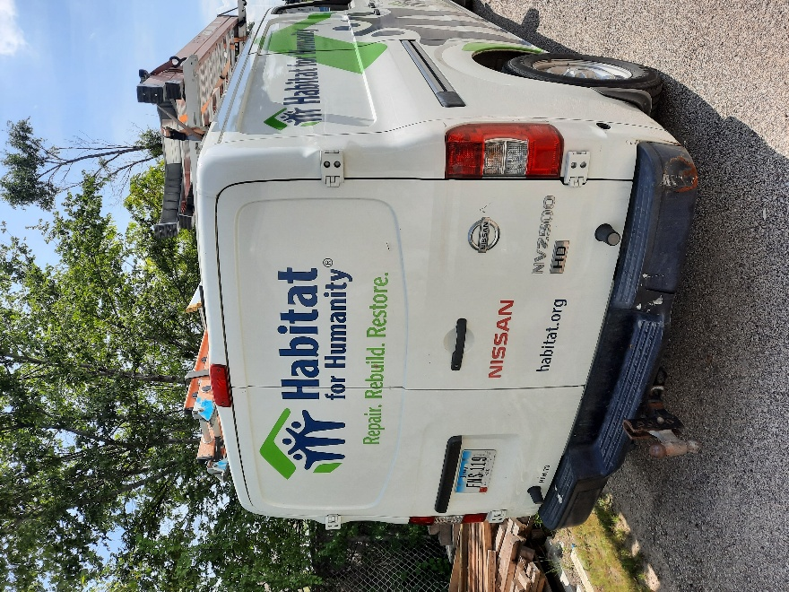
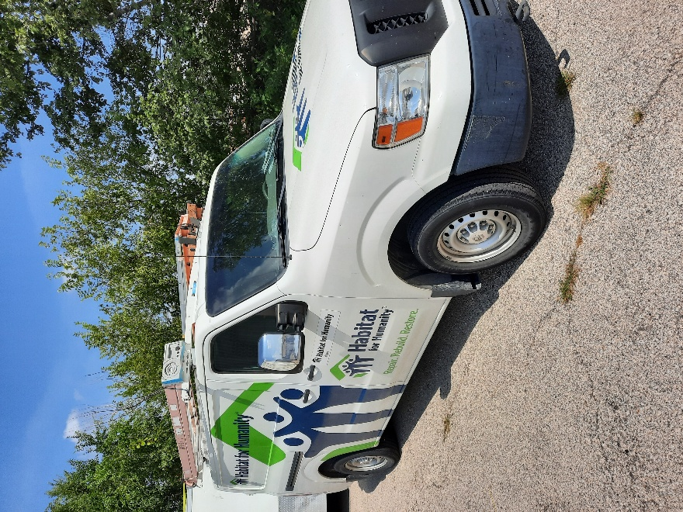
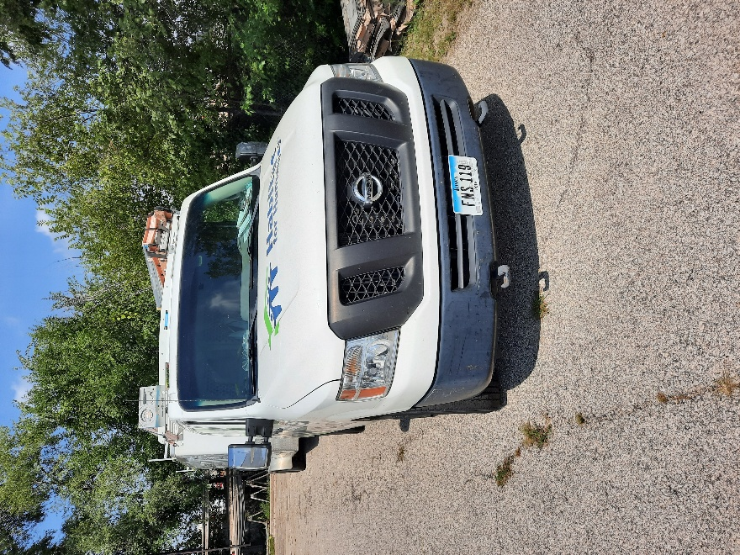
2015 Nissan Nv 2500 Van | White

