**USING MY.AMERICORPS.GOV**

|  |  |  |  |  |  |  |  |  |  |  |  |  |  |  |  |  |  |  |  |
| --- | --- | --- | --- | --- | --- | --- | --- | --- | --- | --- | --- | --- | --- | --- | --- | --- | --- | --- | --- |
| |  |  |  | | --- | --- | --- | | Enrolling with the Program | Before Service | Page 2 | | Forbearance Requests | During Service | Page 3 | | Checking balances | During and After Service | Page 4 | | Accrued interest payments | After Service | Page 5 | | Education Award – Loan Payments | After Service | Page 6 | | My Tax Documents | After Service | Page 7 | |  |

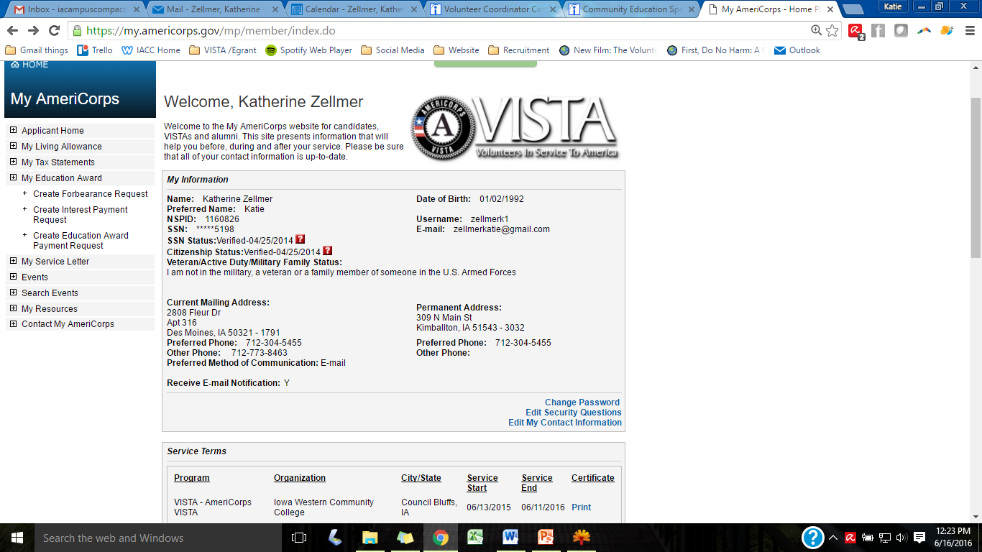

**Before Service-**

Before service my.americorps.gov is a place to search and apply for positions and a platform to connect you to the AmeriCorps program you will be serving. When a member completes the “ENROLLMENT FORM”, the AmeriCorps system does a check on the member citizenship and social security status to ensure they are eligible for service in the United States. This takes anywhere from 4 to 14 days.

**Steps for completing enrollment to join the program**

**Part 1 (if you do not already have an americorps account)**

1. Go to [my.americorps.gov](https://nam11.safelinks.protection.outlook.com/?url=http%3A%2F%2Fmy.americorps.gov%2F&data=05%7C02%7C%7C0ceccb327e5c4c08840508dc653c754b%7C54267b68371949ab99042e9821d03698%7C0%7C0%7C638496557582141835%7CUnknown%7CTWFpbGZsb3d8eyJWIjoiMC4wLjAwMDAiLCJQIjoiV2luMzIiLCJBTiI6Ik1haWwiLCJXVCI6Mn0%3D%7C0%7C%7C%7C&sdata=5rG9xPDe9O81QlGBI71PJt%2FYIK%2FWr6O5TpRbAXHWX3U%3D&reserved=0)
2. Click "Apply to Serve" at the bottom of the screen
3. Fill out pages of information
4. The system will send you an email, which will let you create a username and password

**Part 2: Next or Already have an account:**

1. Sign back into the system and click "**enrollment form**" along the left hand side of the screen
2. Make sure you are in “**Member Home**” and not “**Applicant Home**” along the top
3. Fill out the pages of personal information and click "**save"**

**DURING SERVICE – CREATING A NATIONAL SERVICE FORBEARANCE REQUEST**

* Click on “**Create Forbearance Request**”
* Choose your **service term**
* Click “**search institution**”
  + Here you will need to know the **address and name of your loan holder**. For instance some loans will be with your school while others are through the dept of education loan holders. Everyone is different. Federal Loan Servicing is in Harrisburg, Penn.
  + It helps to put your loan account number in the comment box.
  + This will not work with private loans.
* Submit request, but ensure you only click once. **Repeat for each loan provider**.
* To check your request status, go back to your “My Education Award” page. The loan holders have the option of accepting or rejecting and they will put their decision in the comment box attached to the request.

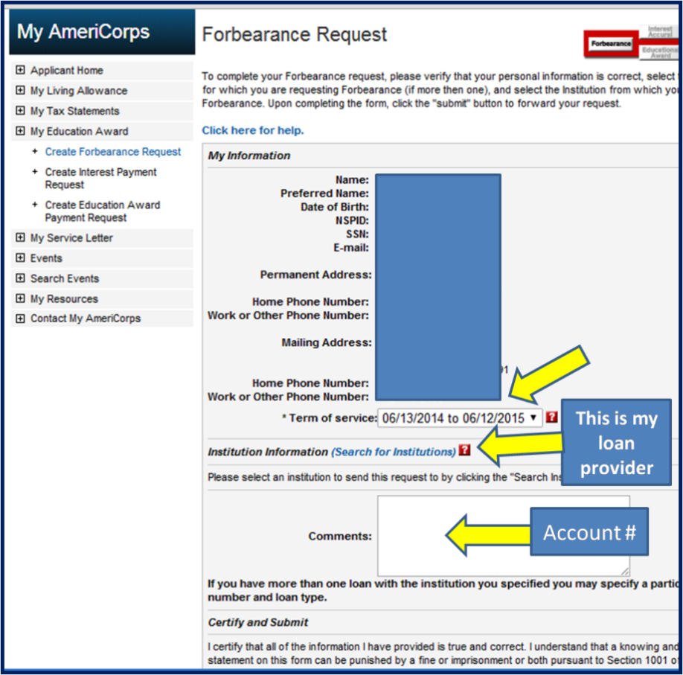

**DURING/AFTER STATUS – CHECKING REQUESTS AND REMAINING BALANCE**

* Click on My Education Award
* Here you can view remaining education award balances
* View any requests made through the My.Americorps system in the middle of the screen by clicking on each request
  + The loan providers and educational institutions have the option of accepting or rejecting and they will put their decision in the comment box attached to the request.

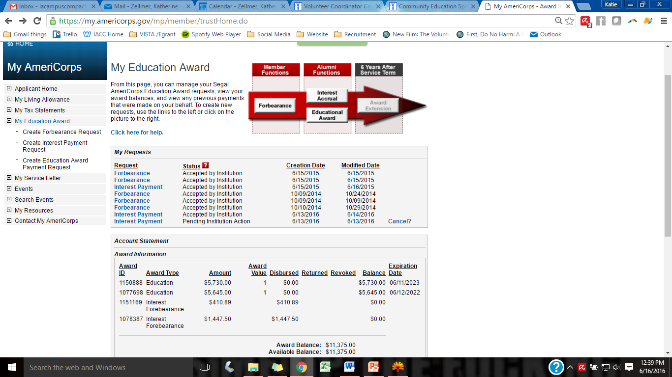

**CREATE ACCRUED INTEREST PAYMENT REQUEST (AFTER SERVICE)**

This will only appear after you have completed your year of service and have been granted your award. *The National Trust will only pay your accrued interest if you have placed your loans into forbearance during the year of service.*

* Click on “Create Interest Payment Request”
* Select Service Term
* “Search for your institutions. These will be the same institutions you had in forbearance. You must know the name and address of your loan provider.
  + Providing your account number in the comments section is helpful
* Click submit ONCE
* To check your request status, go back to your “My Education Award” page. The loan holders have the option of accepting or rejecting and they will put their decision in the comment box attached to the request.

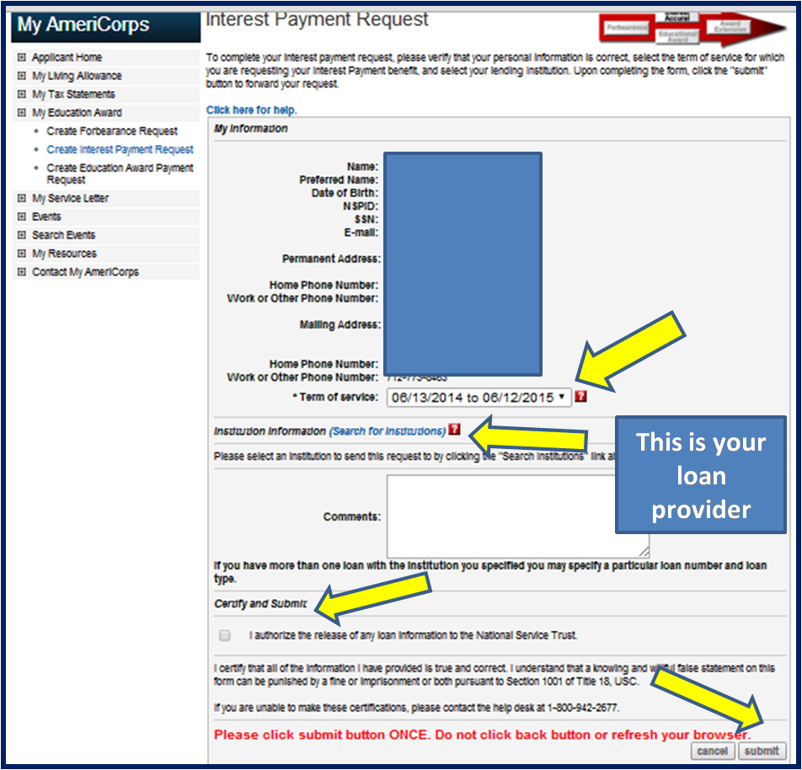

**CREATE EDUCATION AWARD PAYMENT REQUEST (AFTER SERVICE)**

This will only appear after you have completed your year of service and have been granted your award.

* **Click on “Create Education Award Payment Request”**
  + Select **“Education Expenses” or “Loan Payment”**
  + Select the amount you wish to send
  + “Search Institution”
  + Certify and Submit
* **Helpful Hints** <http://www.nationalservice.gov/resources/edaward>
  + Your education award is **considered taxable income**! Beware when using it all at once
  + You have **7 years** to use the award.
  + Any amount of payment sent to loan providers is considered future payments if not specified. So if you pay $1500 and your loan payment is $300 monthly the loan company will assume you are making 5 payments in advance. If you are wanting to pay directly on the principal, you will need to contact the loan provider and let them know how to allocate those funds they received.
  + If paying for education expenses like future tuition, **call your financial aid office** at your school. The education award payment is split in two. One half at the beginning of the year and one half in the middle of the semester.

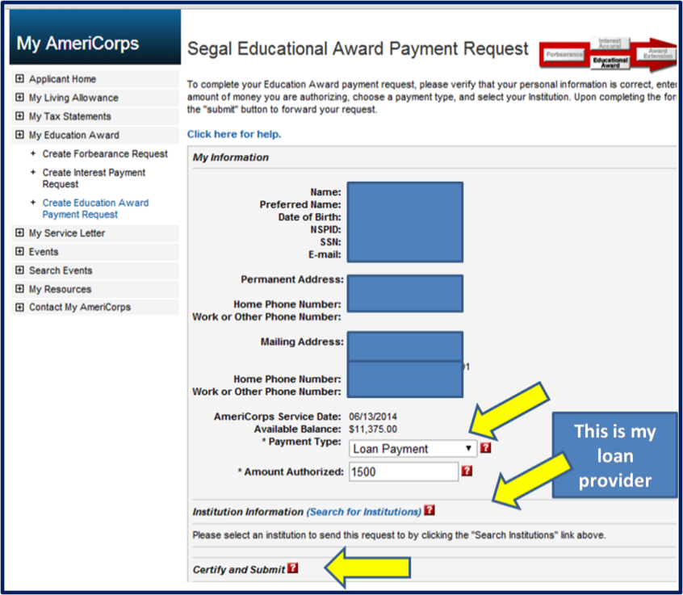

**AFTER SERVICE – GETTING YOUR TAX DOCUMENTS**

* Click “My Taxes Statements”
* 1099 Misc: Interest Accrued payments and education award payments are here

